MARQUIS HOTEL OFFER FOR ELLME2022
Granada (Spain), 22-24 June 2022

To book your accommodation with Marquis Hotels with the special ELLME2022 price, please fill in this form and send it to elena@marquis-hotels.com with the subject ELLME2022 RESERVATION

PRICES AND OPTIONS
Prices are per room (either individual or double occupancy) for the 4 nights of the conference (no breakfast included). Direct payment at your arrival. Cancellation is possible until 1 week prior to arrival. A la carte breakfast can be booked at any of the options but they are all served at Hotel Issabel’s (5 min. walk from any of the other hotels). This prices refer to the conference days (arriving on 21st and leaving on 25th June 2022), if you wish to extend or reduce your stay, please ask the hotel: elena@marquis-hotels.com
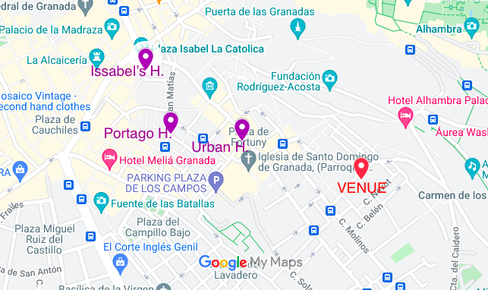

- Hotel Marquis URBAN 3*: 200€/4 nights (individual or double occupancy) Breakfast: 9€ p.p.p.d.

- Hotel Marquis PORTAGO Apartments: 215€/4 nights (individual or double occupancy) Breakfast: 9€ p.p.p.d.

- Hotel Marquis ISSABEL’S 4*: 380€/4 nights (individual or double occupancy) Breakfast: 16€ p.p.p.d.

Please fill in with your details:
- FULL NAME:
- EMAIL:
- MOBILE PHONE:
- DATE OF ARRIVAL (dd/mm/yyyy):
- DATE OF DEPARTURE (dd/mm/yyyy):
- NUMBER OF ROOM/S and OCCUPANCY:
- HOTEL PREFERENCE (please indicate the hotel/s of your preference ranked according to your preference: URBAN / PORTAGO / ISSABEL’S):
  - 1st :
  - 2nd:
  - 3rd:
  - INCLUDE BREAKFAST? Yes or No
- ANY COMMENT:

